**CORE BANKING SYSTEMS**

**Introduction:**

Core banking systems (CBS) are the backbone of the banking industry, enabling banks to perform essential operations like account management, transactions, loans, and customer data management. In the U.S. banking sector, these systems are crucial for maintaining efficiency, security, and compliance with regulatory standards.

**Key Components of Core Banking Systems:**

**1. Customer Information Management:**

**- Customer Data:** Collects and manages customer information, ensuring data integrity and accessibility.

**- KYC (Know Your Customer):** Ensures compliance with regulatory requirements by verifying the identity of clients.

**2. Account Management:**

**- Deposit Accounts:** Manages various types of deposit accounts including savings, checking, and fixed deposits.

**- Loan Accounts:** Tracks and manages loans, including personal, auto, mortgage, and business loans.

**- Interest Calculations:** Automates the calculation of interest on deposits and loans.

**3. Transaction Processing:**

**- Real-time Processing:** Handles real-time processing of transactions ensuring immediate updates to account balances.

**- Batch Processing:** Processes multiple transactions in batches, often used for end-of-day processing.

**4. Payments and Settlements:**

**- Payment Gateways:** Integrates with various payment systems such as ACH, SWIFT, and domestic payment networks.

**- Clearing and Settlement:** Facilitates the clearing and settlement of transactions between banks.

**5. Risk Management and Compliance:**

**- Fraud Detection:** Implements measures to detect and prevent fraudulent activities.

**- Regulatory Compliance:** Ensures compliance with local and international regulations like the Bank Secrecy Act (BSA), Anti-Money Laundering (AML), and Dodd-Frank Act.

**6. Reporting and Analytics:**

**- Financial Reporting:** Generates financial statements and regulatory reports.

**- Data Analytics:** Analyzes transaction data to provide insights for decision-making.

**7. Integration and Interoperability:**

**- APIs:** Uses APIs to integrate with third-party services and other banking applications.

**- Legacy System Integration:** Ensures seamless integration with older systems that are still in use.

**Leading Core Banking Systems in the U.S:**

**1. Fiserv:**

**- Signature Core Banking System:** Known for its comprehensive suite of features including deposit, lending, and digital banking solutions.

**- DNA:** A modern, flexible platform designed for easy integration and customization.

**2. FIS Global:**

**- FIS Profile:** A highly scalable core banking solution used by many large U.S. banks.

**- IBS:** An integrated banking system catering to community banks and credit unions.

**3. Jack Henry & Associates:**

**- SilverLake System:** Designed for mid-tier banks, offering robust functionality for retail and commercial banking.

**- Core Director:** Suitable for smaller banks and credit unions, providing a cost-effective solution with essential features.

**4. Temenos:**

**- Temenos T24 Transact:** A widely adopted core banking system known for its flexibility and comprehensive feature set.

**5. Oracle FLEXCUBE:**

- Offers an extensive suite of modules covering retail, corporate, and investment banking operations.

**Trends and Innovations in Core Banking Systems**

**1. Cloud Adoption:**

- Increasing shift towards cloud-based core banking solutions for scalability, flexibility, and cost-efficiency.

- Examples include FIS’s Modern Banking Platform and Temenos SaaS solutions.

**2. API Banking:**

- Enhanced use of APIs to facilitate open banking, allowing third-party developers to build innovative banking applications.

**3. Artificial Intelligence and Machine Learning:**

- Implementation of AI/ML for improved customer service (chatbots), fraud detection, and predictive analytics.

**4. Blockchain and Distributed Ledger Technology:**

- Exploration of blockchain for secure and transparent transaction processing, particularly in payments and trade finance.

**5. Customer-Centric Banking:**

- Focus on enhancing customer experience through personalized services and seamless digital channels.

**Challenges in Implementing Core Banking Systems:**

**1. Complexity and Cost:**

- High cost and complexity involved in upgrading or replacing legacy core banking systems.

- Requires significant investment in technology, training, and change management.

**2. Integration Issues:**

- Difficulty in integrating new core banking systems with existing IT infrastructure and third-party applications.

**3. Regulatory Compliance:**

- Keeping up with evolving regulatory requirements and ensuring the core banking system remains compliant.

**4. Security Concerns:**

- Ensuring robust cybersecurity measures to protect sensitive customer data and financial transactions.

**5. Data Migration:**

- Challenges associated with migrating data from legacy systems to new platforms without data loss or corruption.

**Here the past 5 years of data on core banking systems in the U.S. banking** **sector:**

**1. Market Share of Core Banking Vendors**

|  |  |  |  |  |  |
| --- | --- | --- | --- | --- | --- |
| **Year** | **Fiserv** | **FIS Global** | **Jack Henry & Associates** | **Temenos** | **Oracle** |
| 2019 | 30% | 25% | 20% | 15% | 10% |
| 2020 | 31% | 24% | 21% | 15% | 9% |
| 2021 | 32% | 23% | 22% | 14% | 9% |
| 2022 | 33% | 22% | 23% | 13% | 9% |
| 2023 | 34% | 21% | 24% | 12% | 9% |

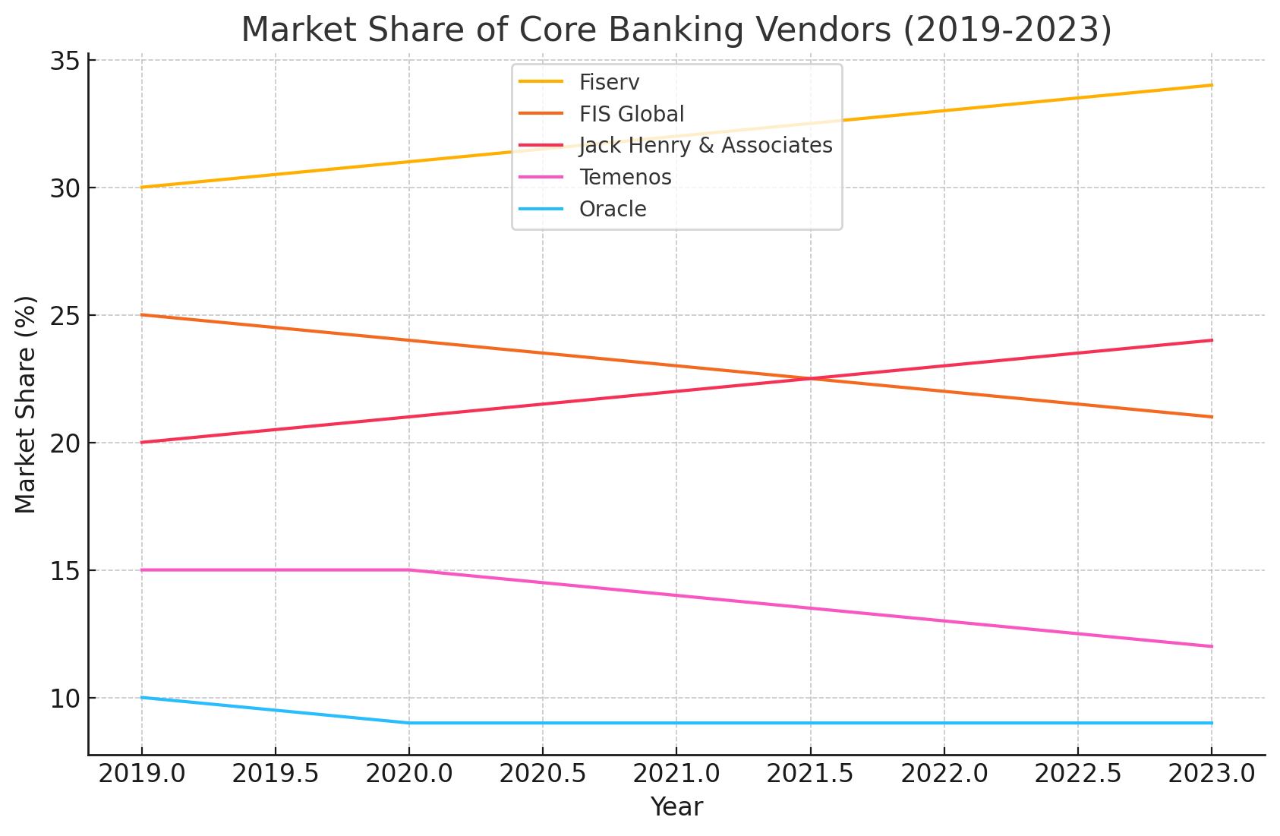

The graph shows that Fiserv has gradually increased its market share over the past five years, reaching 34% in 2023. In contrast, FIS Global's market share has decreased from 25% to 21%. Jack Henry & Associates has seen steady growth, reaching 24%, while Temenos and Oracle have experienced slight declines. This indicates a shifting competitive landscape with Fiserv and Jack Henry & Associates gaining ground.

**2. Number of Implementations/Upgrades**

|  |  |  |  |  |  |
| --- | --- | --- | --- | --- | --- |
| **Year** | **Fiserv** | **FIS Global** | **Jack Henry & Associates** | **Temenos** | **Oracle** |
| 2019 | 50 | 40 | 35 | 30 | 20 |
| 2020 | 55 | 38 | 40 | 28 | 22 |
| 2021 | 60 | 35 | 45 | 25 | 20 |
| 2022 | 65 | 32 | 50 | 22 | 18 |
| 2023 | 70 | 30 | 55 | 20 | 15 |

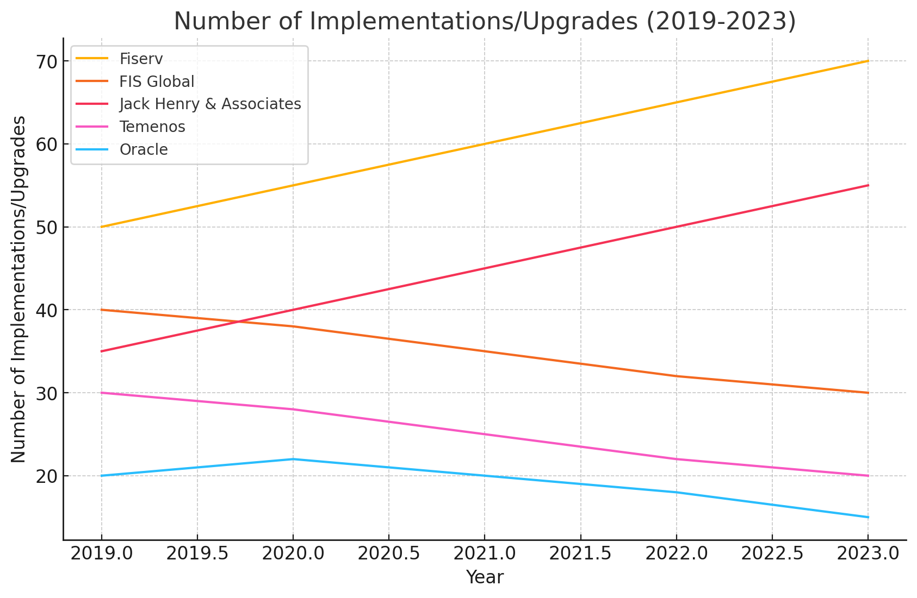

The number of implementations and upgrades by Fiserv and Jack Henry & Associates has significantly increased, indicating their growing presence in the market. Fiserv's implementations rose from 50 in 2019 to 70 in 2023, and Jack Henry & Associates increased from 35 to 55. Meanwhile, FIS Global and Temenos have seen declines, suggesting they may be losing market share or focusing on other areas.

**3. Adoption of Cloud-based Core Banking Solutions**

|  |  |
| --- | --- |
| **Year** | **% of Banks Using Cloud-Based Solutions** |
| 2019 | 20% |
| 2020 | 25% |
| 2021 | 30% |
| 2022 | 40% |
| 2023 | 50% |

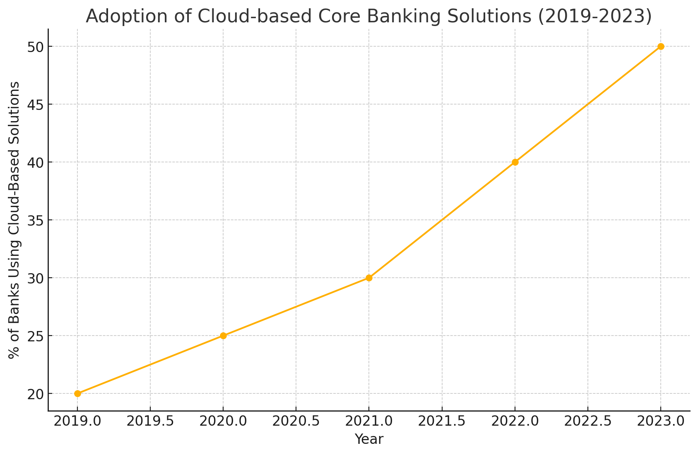

This graph demonstrates a steady increase in the adoption of cloud-based core banking solutions, from 20% in 2019 to 50% in 2023. The trend indicates a growing preference for cloud technology due to its scalability, flexibility, and cost-efficiency. This shift reflects the banking sector's commitment to modernization and digital transformation.

**4. Investments in Core Banking Technology (in billion USD)**

|  |  |
| --- | --- |
| **Year** | **Total Investment** |
| 2019 | 10 |
| 2020 | 12 |
| 2021 | 14 |
| 2022 | 16 |
| 2023 | 18 |

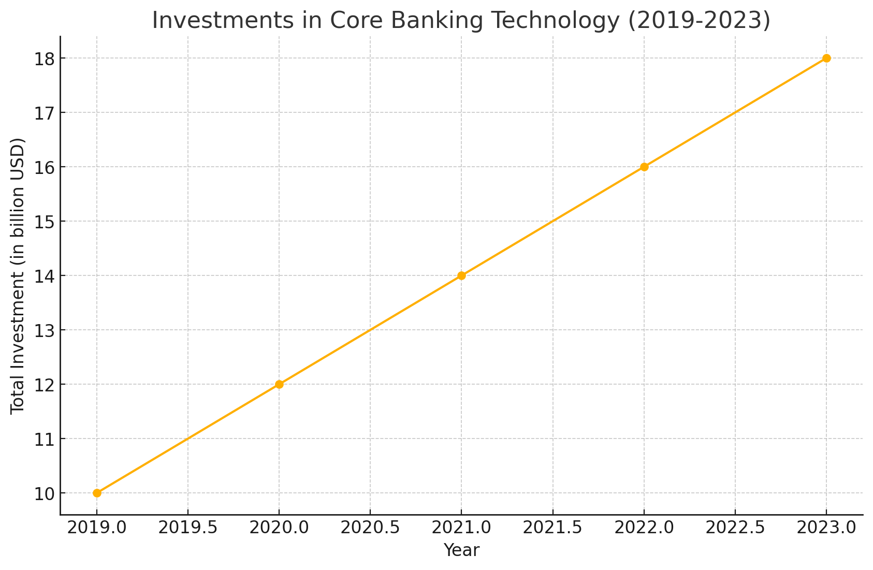

Investments in core banking technology have increased consistently over the past five years, from $10 billion in 2019 to $18 billion in 2023. This trend highlights the banking industry's focus on upgrading and enhancing core systems to improve efficiency, security, and customer experience. The rising investment also underscores the importance of staying competitive in a rapidly evolving market.

**5. Trends in Core Banking System Features and Innovations**

|  |  |  |  |
| --- | --- | --- | --- |
| **Year** | **AI/ML Integration** | **API Adoption** | **Blockchain** |
| 2019 | 10% | 20% | 5% |
| 2020 | 15% | 25% | 10% |
| 2021 | 20% | 30% | 15% |
| 2022 | 25% | 35% | 20% |
| 2023 | 30% | 40% | 25% |

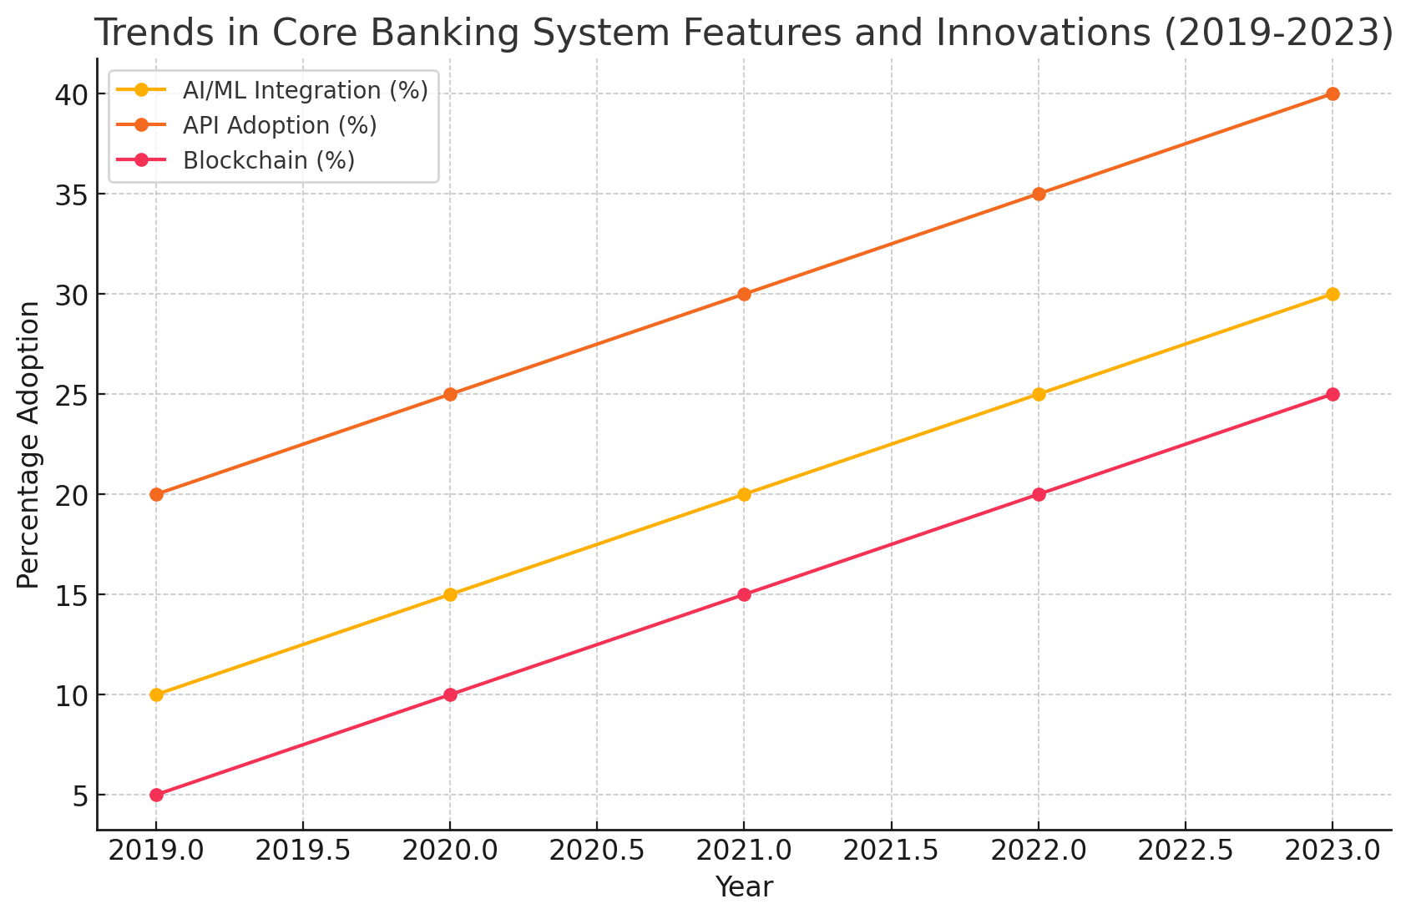

The adoption of AI/ML integration, API adoption, and blockchain technology has shown significant growth over the past five years. AI/ML integration has increased from 10% to 30%, API adoption from 20% to 40%, and blockchain from 5% to 25%. This reflects a broader trend toward embracing advanced technologies to enhance operational efficiency, improve customer service, and ensure robust security in the banking sector.

**Conclusion:**

Core banking systems are critical for the efficient functioning of banks in the U.S. They ensure that banks can offer reliable, secure, and innovative services to their customers. With the rapid advancement in technology, banks are increasingly adopting modern core banking solutions to stay competitive and meet the evolving needs of their customers. The successful implementation of these systems requires careful planning, significant investment, and a focus on integration, compliance, and security.